Into The Wild Expedition Rentals
Owner: Matt Reichel
Phone: 612-419-9604
Email:info@intothewildexpeditionrentals.com

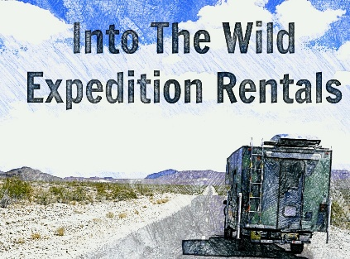

To Whom It May Concern,
Into The Wild Expedition Rentals will be launching in the spring of 2015 as an outdoor expedition and overland travel business. The focal point of the company will be directed towards off grid camping, overland vehicles, and expedition gear. The motivation behind Into The Wild Expedition Rentals is to offer affordable rentals to people who want to do extended overland or backcountry camping but don’t have the time or finances to build their own expedition vehicle.
Into the Wild Expedition Rentals is based out of Denver, Colorado which offers a large demographic for outdoor enthusiasts with a high tourism volume from the Denver International Airport. Currently we are building our fleet of vehicles and gear inventory in preparation for the 2015 rental season. Into the Wild Expedition Rentals is interested in creating a partnership with your company. We believe the products you provide would blend well with our business plan.
Benefits would include increased visibility for your company in Colorado and the Rocky Mountain region. Options for advertisement include but are not limited to visibility on the website, visibility on our vehicles, and increased traffic for you via the Into The Wild Expedition Rentals social media websites. These media sites would then be linked to your home website. We also offer the option of working as a vendor or product ambassador. With Into The Wild Expedition Rentals you will have people and equipment entrenched in the key market areas of your product or service.
Into The Wild Rentals is also interested in your ideas on creating a partnership that will benefit both parties. Please contact Owner Matt Reichel at info@intothewildexpeditionrentals.com
Please check out our website – IntoTheWildExpeditionRentals.com
Also check out Matt Reichel’s overland adventures at MilesintheMirror.com

